**Connect to your Linux Instance from Windows Local Machine**

After your EC2 linux instance is launched, you can now connect to the very instance, execute commands, install software packages and services, and transfer files between your local computer and your instance.

Following are the connection options you can opt for if your local computer operating system is Windows.

* Putty
* SSH Client
* AWS Systems Manager Session Manager

This document will show you an in-depth and step-by-step process to connect to your EC2 linux instance.

**Connect to your Linux instance from Windows using PuTTY**

The following instructions explain how to connect to your instance using PuTTY, a free SSH client for Windows.

1. Install PuTTY and PuTTYgen on your local computer. Click on the following link: <https://www.chiark.greenend.org.uk/~sgtatham/putty/latest.html>

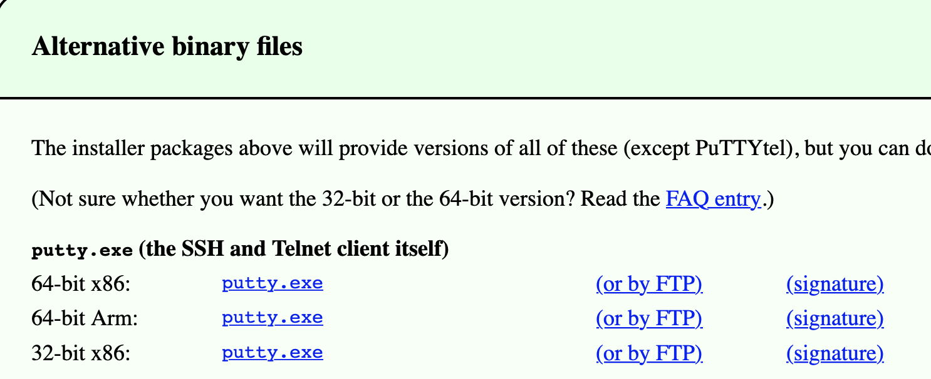

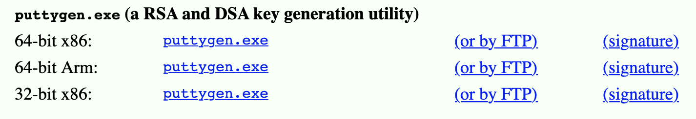

We will use PuTTY to get connected to our Linux instance while PuTTYgen will be used to convert the .pem key to .ppk format.

### **Convert your private key using PuTTYgen:** PuTTY does not natively support the private key format for SSH keys. PuTTY provides a tool named PuTTYgen, which converts keys to the required format for PuTTY. You must convert your private key (.pem file) into this format (.ppk file) as follows in order to connect to your instance using PuTTY.

1. Open PuTTYgen (PuTTY Key Generator) and click **Load**.

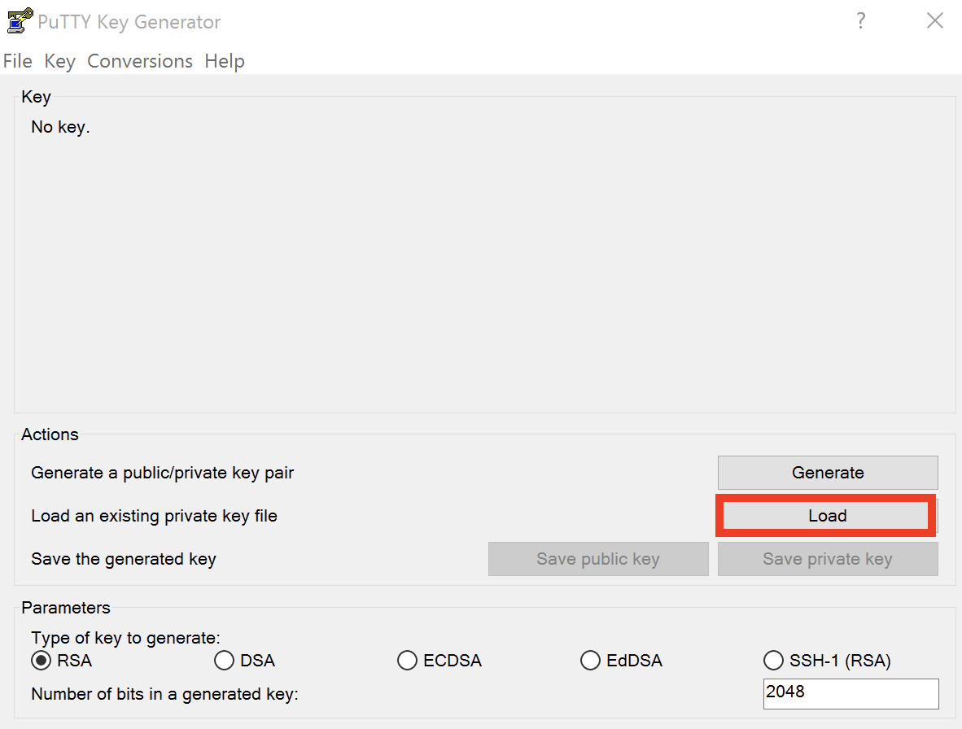

1. On **Load Private Key** window, make sure that you choose **All Files (*.*)** so that .pem keys also show up.

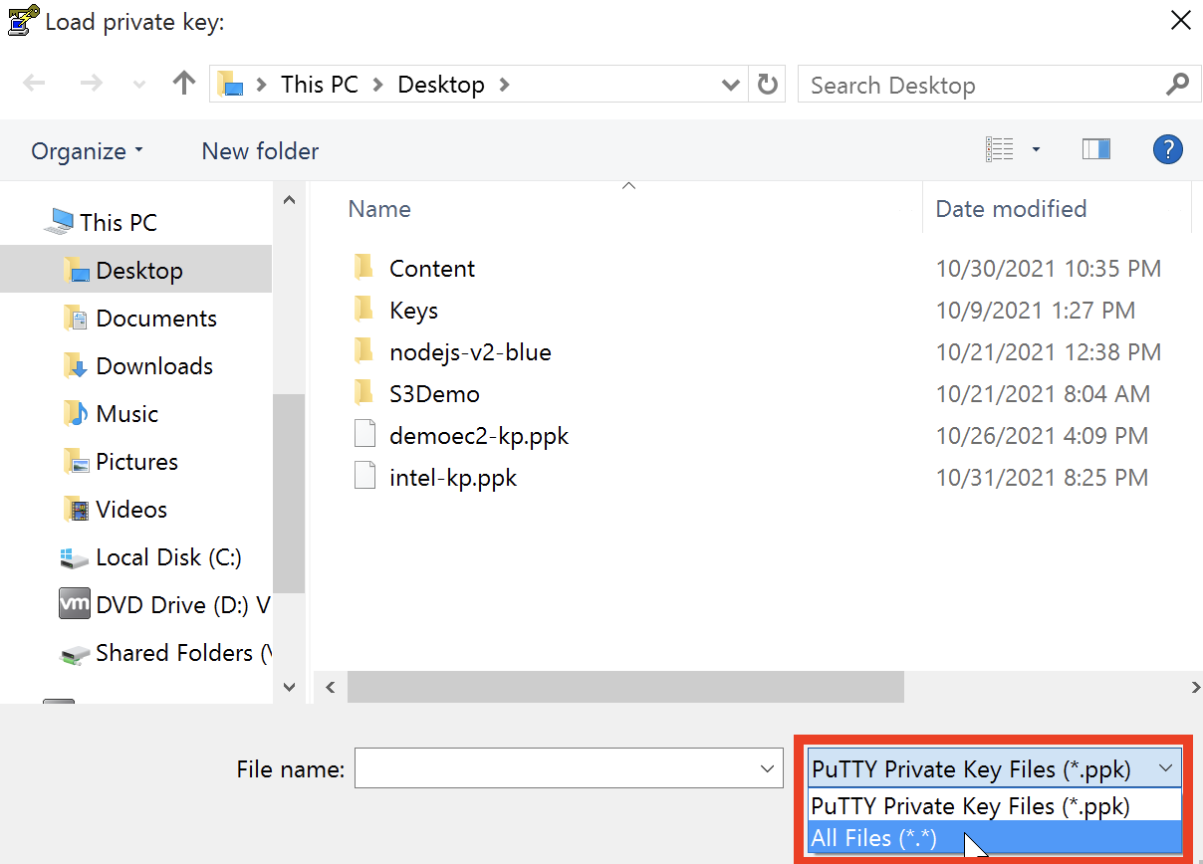

1. Search for the private (.pem) key and click **Open**.

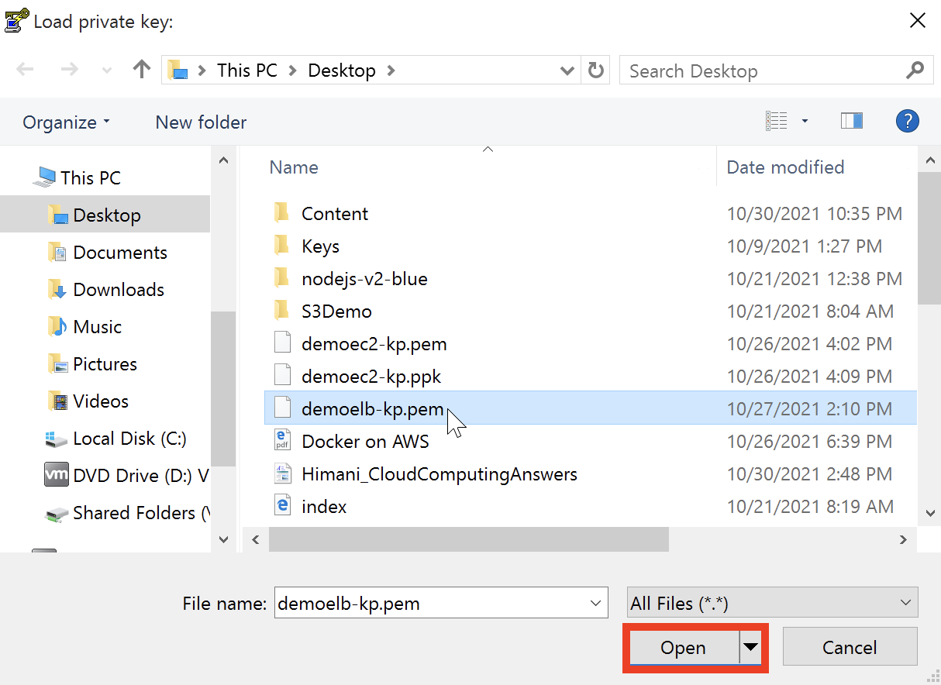

1. Press **OK** on this PuTTYgen Notice window.

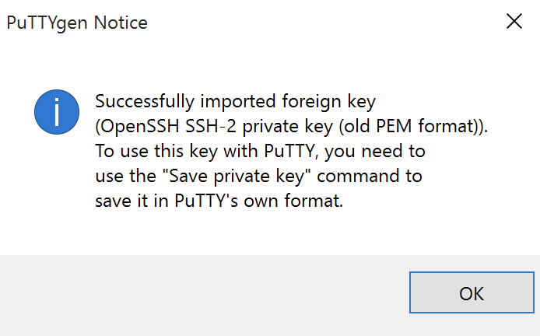

1. This will eventually load the contents of the private (.pem) key. Click **Save private key** to save this key into .ppk format.

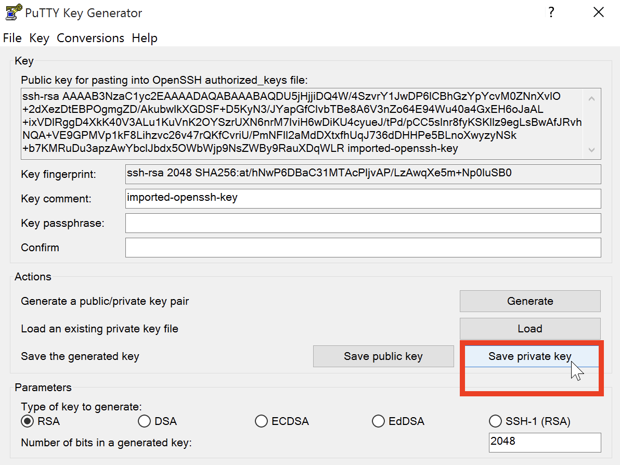

1. Press **Yes** on the PuTTYgen Warning window as we will be saving this key without a passphrase to protect it.

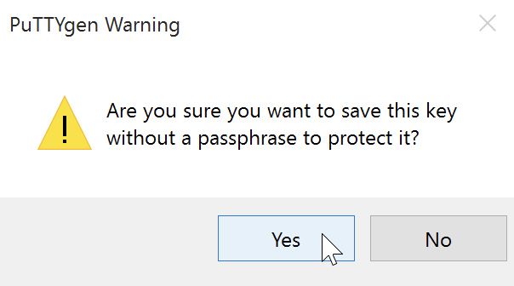

**Note:** A passphrase on a private key is an extra layer of protection. Even if your private key is discovered, it can't be used without the passphrase. The downside to using a passphrase is that it makes automation harder because human intervention is needed to log on to an instance, or to copy files to an instance.

1. Assign a name to this .ppk key and click **Save** to save this very key on to your preferred location on your Windows local machine.

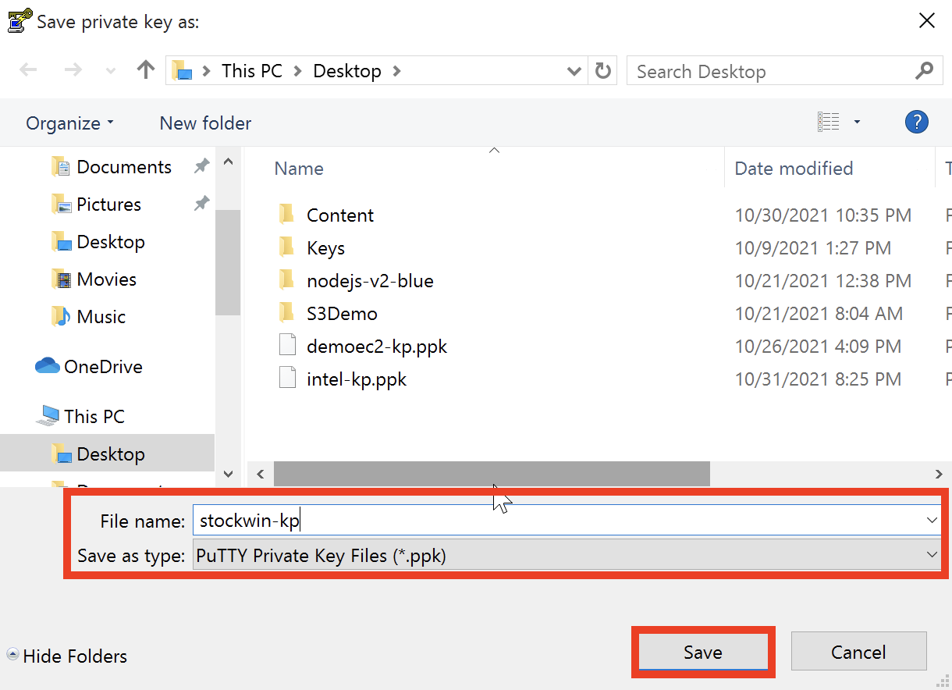

3.  **Connect to your Instance using PuTTY:** Use the following procedure to connect to your Linux instance using PuTTY.

1. Start PuTTY
2. In the **Category** pane, choose **Session** and complete the following fields:

* In the **Host Name** box, mention either the Public IP address or the Public IPv4 DNS name of the linux instance.
* To fetch this information, select the instance, go to **Details** and from here you can copy either the Public IP address or the Public IPv4 DNS name of this very instance.

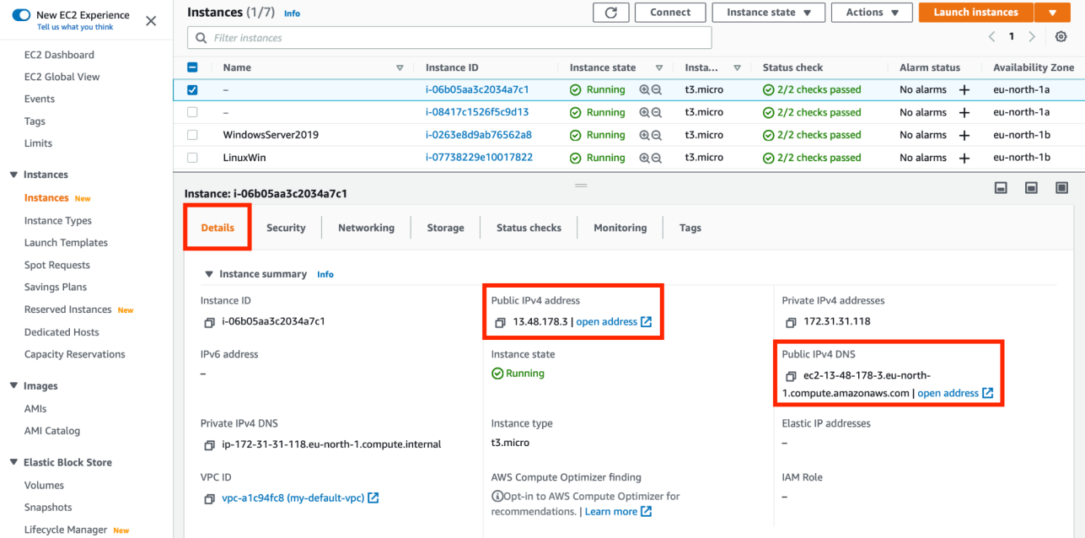

* Ensure that the Port value is 22.
* Under Connection type, select SSH.

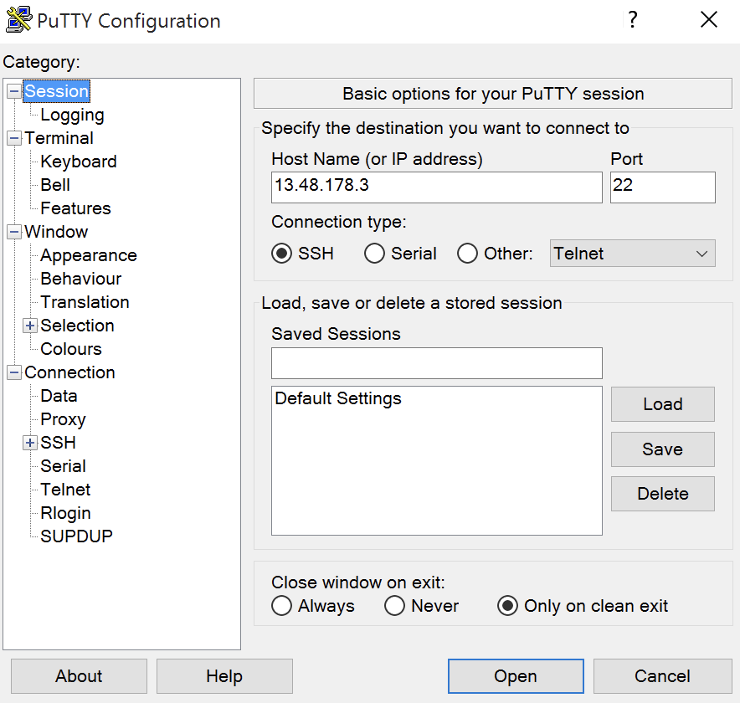

In the Category pane, expand **Connection**, expand **SSH**, and then choose **Auth**. Complete the following:

* Choose **Browse**
* Select the .ppk file that you generated for your key pair and choose **Open**

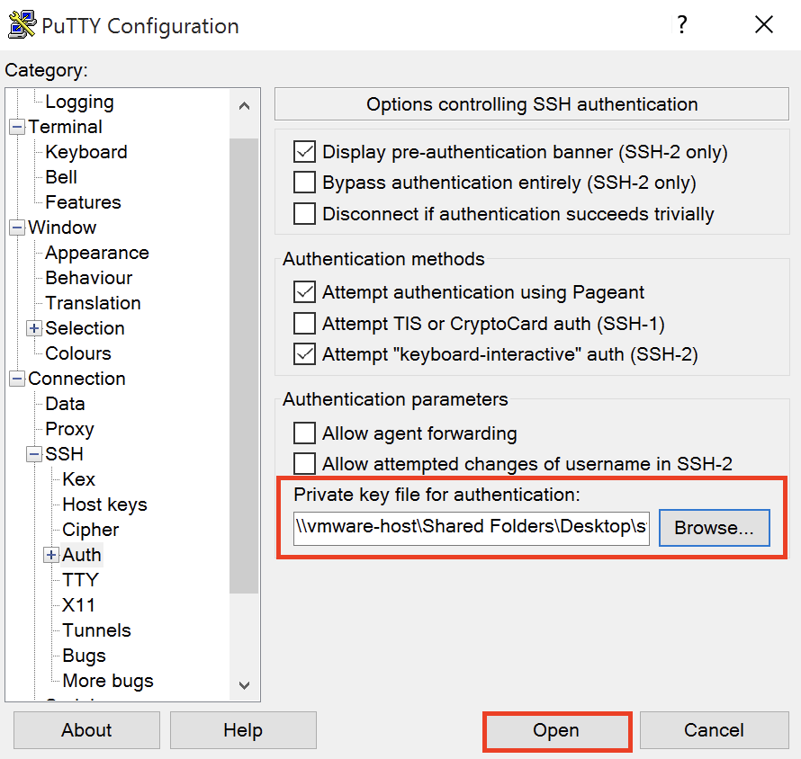

* If this is the first time you have connected to this instance, PuTTY displays a security alert dialog box that asks whether you trust the host to which you are connecting. Choose **Yes** or **Accept**. A window opens and you get connected to your instance.

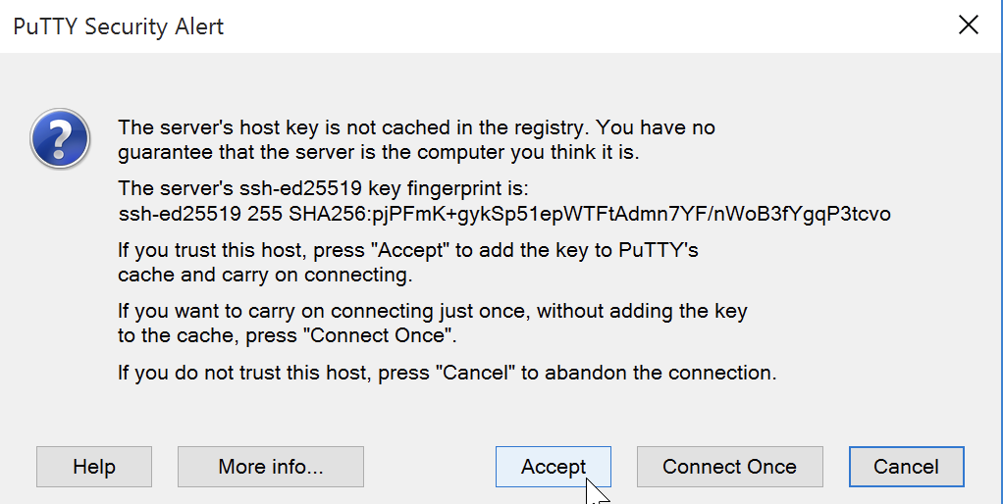

* Once connected, type-in the username (default username for Amazon Linux instance is ‘ec2-user’ and for Ubuntu instance is ‘ubuntu’).

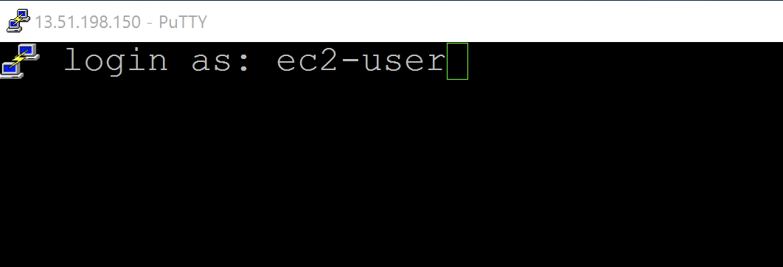

* Press Enter so that you’re being authenticated and get shell access to your EC2 linux instance. From here you can start executing the linux based commands.

